**An Investigation into Creating Subtitles for A Virtual Environment Game.**

Louca K. Coles

1 Computer Science and Creative Technologies, University of The West of England, Bristol, England

*Abstract* - **In recent years, virtual reality (VR) has become a major part of the video game industry, seeing VR re-releases of games like DOOM (2016) (iD Software, 2016) and The Elder Scrolls V: Skyrim (Bethesda Game Studio, 2011) as well as a ton of original games such as Job Simulator (Owlchemy Labs, 2016) and Robo Recall (Epic Games, 2017). However, as with non-VR based games, most of these lacks various accessibility, especially within the subtitles area. The objective of this project was to create a system within the Unity game engine that can be used to display subtitles of a game within a variety of context and designs. Using a PS4 Developer Kit and PSVR hardware, participants will play through one of three levels, each with its own unique feel and context. They will also be using one of two perspectives, a first-person perspective and third person perspective.**

*Index Terms* **- Virtual Reality; Subtitles; Accessibility; PSVR; PlayStation 4; Unity Game Engine.**

**I. INTRODUCTION**

Over the years VR has become more accessible to gamers, with the prices of hardware like the Oculus Rift and HTC VIVE dropping, Sony releasing the PSVR kit that can allow gamers who own a PlayStation 4 (PS4) to play VR games using their console and the release of mobile based headsets like the Samsung Gear VR and Google Daydream. This means that even more people can play and use VR including those less abled. This means that a range of accessibility features should be implemented into these VR systems and VR games, however, most of the time they are not and even today some non-VR based games also lack these features. The focus of this investigation is subtitles and implementing that accessibility feature for a prototype VR game that could be played using the PS4 and PSVR hardware.

**II. THEORETICAL CONSIDERATIONS**

**2.1 Guidelines on Creating Subtitles**

TV shows, films and most video games can display subtitles in some form. In films and TV shows, the subtitles follow a specific set of guidelines, for example the BBC (2018) have a set of guidelines that anyone who is handling or providing subtitles for them should follow.

However, subtitles in video games do not follow any specific guidelines and in some cases are so poorly implemented that no one can use them, however Ian Hamilton (2015) has compiled a list of guidelines that can be used for all types of video games to create readable and usable subtitles. Some of the points made in this list are amplified when the video game is being played within VR. For example, due to the ability to view all 360° of the environment, indicating the direction of where the sound is coming from or even the positioning of the subtitle is even more vital than usual.

**2.2 Flow**

Flow is a vital part of game development as the theory defines flow as a state of absolute absorption in the activity a person is doing as stated by Csikszentmihalyi (1990). For a person to be in a state of flow, there must be a certain level of concentration. Overall, Csikszentmihalyi (1990) states there are eight components of flow which are:

* We must confront tasks we have a chance in completing
* We must be able to concentrate on what we are doing
* The task has clear goals
* The task provides immediate feedback
* One acts with deep, but effortless involvement, that removes from awareness of the worries and frustrations of everyday life
* One exercises a sense of control over their actions
* Concern for the self disappears, yet, paradoxically the sense of self emerges stronger after the flow experience is over
* The sense of duration of time is altered.

Not all these components are required to have an experience of flow but specifically for subtitles and virtual reality there are a few that will be required. Firstly, the player must be able to concentrate on what they are trying to do. This links back to subtitles and how they are displayed within a video game, especially one that can be played within VR.

In Ian Hamilton’s (2015) guidelines, he states that the subtitles should be placed at the center/bottom of the screen, however there isn’t really a center/bottom of the screen when the player has 360° of freedom. This means that some sort of adaptation of certain guidelines might be needed.

Specifically, for subtitles in VR, the subtitles shouldn’t obstruct the player’s view and what they are trying to look at as this would break their concentration and therefore remove that component of flow from the equation.

Secondly, the task must have a clear goal. Subtitles in general are used for a wide range of reasons, but to summaries it’s to allow the viewer to have a sense of context of the current scene, whether that is because there are less abled or are likely to miss something that is said in an intense scene. Therefore, to provide an accurate context and imply a clear goal of the game, the design and behaviours of the subtitles must follow a set rules to achieve this.

Design wise the subtitles could use of combination of the guidelines suggested by both the BBC (2018) and Ian Hamilton (2015). As for the behaviours of the subtitles, the placement and the rotation of the subtitles would be vital as if positioned in such a way it might be possible for the player to miss the subtitles entirely and therefore not have a clear idea of what the goals of the current level and possibly even the game.

**2.3 360° Video Subtitles**

As mentioned before some adaptation of the guidelines suggested by Ian Hamilton (2015) might be needed, this is where the research done by the BBC research and development team comes into play which was outlined by Brown and Patterson (2017). This team did research into displaying subtitles in a variety of ways, one way is the subtitle constantly being displayed in front of the player and another was to have the subtitle stay at its initial position and then when the player has looked far enough the subtitle will move to be in front of where the player is looking as stated by Brown and Patterson (2017).

**2.4 Research Questions and Hypothesis**

Based on the research into the topic area for subtitles and how they would be displayed within a virtual reality environment, a set of research questions have been outlined.

RQ1: Do the guidelines set for films and TV shows used by the BBC (2018) translate directly to video games that are played using virtual reality hardware?

RQ2: Can a combination of the guidelines set for films and TV shows used by the BBC (2018) and the guidelines suggested by Ian Hamilton (2015) provide subtitles that do not break the players experience of flow?

RQ3: Does the subtitle behaviours defined by the BBC research and development team (2017) translate to a virtual reality game?

With these research questions a set of corresponding hypotheses can be made, using the research already covered.

H1: The guidelines for subtitles within films and TV shows have been proven to work as suggested by Ian Hamilton (2015), so in theory there should be no issue with using them within VR based games and even video games in general. The problem is that the overall style that those guidelines provide would not match with a games overall theme and style, which would then break the player’s immersion.

H2: As mentioned previously by just using the guidelines for films and TV shows would be different styling to the game’s style, however, using a combination of the two, would allow for the designers to keep the subtitles in the style that suits the game to some extent but maintain the advantages like the text being clear enough for the user to read.

H3: While 360° Videos can be viewed using VR headsets, they lack the positional tracking aspect that is used within VR based games. Hence the player in a VR environment can move around their environment and therefore some, if not all the defined behaviours will not translate as well initially. However, there are possible adjustments that can be made to each on that would consider of the positional tracking.

**III. METHOD**

**3.1 Participants**

The participants (n = 9) are apart from the Games Technology undergraduate course at the University of the West of England. Each participant was given an approved consent form that detailed the experiment that they were taking part in as well as telling them that they could opt out of the experiment and study at any point in time.

**3.2 Hardware and Software**

In terms of the hardware that was used for the user testing, was a PSVR kit, PS4 Developer Kit and a desktop pc. As for the software that will be used was the Unity game engine version 5.6.3 (2017) and the Neighbourhood for PS4 program. The Unity game engine was used to develop the prototype scenarios for user testing and can then be used to make an executable build that can be pushed to the PS4 Developer Kit through the Neighbourhood program.

**3.3 Stimulus Material**

Within the prototype there are three short levels that can be played through. Each level has its own gameplay theme. The first level is a simplified variation of a typical level that can be found in modern day shooters, where the player must defeat a group of enemies before trying to escape the level before everything explodes.

The second level is an arena styled level that can be found in a variety of shooters such as the Gears of War series (Epic Games, 2006) and the Borderlands series (Gearbox Software, 2009). The player must defeat a set number of enemies every wave to progress to the next wave. Then once the player has passed a set number of waves without dying they can complete the level.

The third and final level is a puzzle game where there are two keys that are randomly hidden in a grid. The player must find both to unlock the door. However, if the player makes an incorrect guess then everything resets, and the keys are randomly hidden again.

Initially the third level contained boxes, one of which would contain a key that would unlock the door. However, through the initial user testing, it was discovered that it was impossible to complete within the third person perspective as the player had limited aiming on the vertical plane and therefore couldn’t hit any of those boxes.

Each of these levels provide some variation of gameplay and can have matching themed subtitles besides the second level, which have the subtitles designed to match the specific guidelines used for subtitles in films and TV shows.

**3.4 Measures**

To answer the outlined research questions, a set of measures will need to be put in place. Each participant will answer a questionnaire (see Figure 1 and Figure 2) that have various questions that will help determine the scale of success for each research question. For the first research question there will need to be a design for the subtitles that follows the guidelines set out by the BBC (2018). This design will then be used in a specific level that the user testers could play.

A similar measure is used to help answer the second research question, where the other levels will have designs for the subtitles specifically suited and/or themed around the level. All the designs used will be rated by the participants based on the clarity of the subtitles as well as how much obstruction was caused by the subtitles.

The third research question is about the subtitles behaviours within the game. Within each level the subtitles behaviours is randomized, which would allow each behaviours to be experience in a wide range of scenarios and placements. This will help identify where a specific behaviours would work and not work as well as outline any behaviours that are not suitable to be used within a VR based game.

**3.5 Codebase Testing**

While not specifically tested, part of the initial project was to give the codebase to other developers to test and see how it handles. Unfortunately, this wasn’t tested due to the average development time needed to full test the codebase, is longer than the time allocated for the development of the project.

While it wasn’t possible to test, research was carried out in how that testing might be carried out and what sort of research questions would be answered.

The testing would be done like that of Adobe do with their user testing as outlined by Babich (2017). The codebase would be given to a variety of group, made up of designers and programmers. Each group will vary in skill level. They will then be asked to fill out a questionnaire that would help answer the research questions but also provide important feedback that would be used to help improve the codebase and the tools provided with it.

The research questions are as followed:

R1: How efficient are the tools, used to create the various data required for the subtitle system, for the developers?

R2: How easy are the tools to use by the developers.

R3: How easy it is to integrate the overall system, into a pre-existing code base?

**IV. RESULTS**

There were two sets of user testing that was carried out for this project, the first being a pre-test session (n=4) and the second being the final test session (n=5). The first session helped outline a few issues with the overall project but also was able to get some initial results to help answer the outlined research questions.

After fixing the issues that arose from the initial user testing session, a new questionnaire was set up and used to gather some more results. In total there were 9 participants (see Figure 1 & Figure 2).

**4.1 Initial Testing**

The initial testing will not help define the results of the first two research questions as some of the questions and the state of the program don’t relate to the research questions that have been outlined. For example, the first research question asks if the guidelines set by the BBC (2018) for TV and films could be used for subtitles in video games and in VR, however, at this point a design based on those guidelines was not implemented. Therefore, that research question cannot be answered.

While this might be the case, it gives an early indication about the behaviours of the subtitles within VR. This will help with answering the third research question. Out of the 4 testers, 3 of them had subtitles when they played through their specific level. 66.7% of the testers had the behaviours in which the subtitles would be displayed at the source of the sound and then billboard to face the player. The 33.3% of the testers had the behaviours in which the subtitles would be displayed in front of the player and then static until they disappeared.

The third research question asks if the behaviours defined by the BBC’s Research and Development team can be translated and used in a full VR game. From the initial questionnaire, 66.6% of the testers that had subtitles on (see Figure 3), gave a rating of 4+ when asked how well the behaviours worked in the perspective that they played in (see Figure 4). The scale was 1 being the subtitles were impossible to see and 5 being the subtitles were easy to see.

There was also 100% no obstruction caused by specifically the behaviours of the subtitles when the testers where playing their levels (see Figure 5). From this it can be inferred that the behaviours can in fact be transferred and replicated in a VR based game.

When shown and then asked which behaviours, that was implemented, they preferred the results were spread, 25% going to both in front of the player constantly and in front of the player then static in position and rotation. The final 50% went to the subtitles being positioned at the source of the sound (see Figure 6).

**4.2 Proposed Final Testing**

The first research questions ask if the BBC (2018) guidelines for subtitles be translated to be used for subtitles within a VR, the answer is yes, they can. Give a designer the right tools and those guidelines and examples can be replicated as the screenshot shows. However, it’s not as simple as that, those guidelines are there and have been for a long time due to their effectiveness, the real question is does that effectiveness transfer over as well.

50% of the testers had subtitles that were stylized using the BBC’s (2018) guidelines and 50% used a design that uses a combination of the BBC’s (2018) and Ian Hamilton’s (2015) guidelines (see Figure 7). Overall an average rating of 3.5/5 was given in both clearness and readability (see Figures 8 & 9). Neither designs distracted or obstruct the player from the game (see Figures 10 & 11).

In the first hypothesis, it was stated that due to the design not being like the overall game design, the player is more likely to be distracted due to the oddness. However, from the user testing it’s clear that the design based on the BBC’s (2018) guidelines didn’t cause any distraction.

The second research question is like the first but asks if a combination of the two guidelines can be used to design better subtitles. In the hypothesis, it was stated that the combination should allow for the clarity and readability but also less likely to distract the player due to both design of the subtitles and game will be the same.

There was one user tester that had a combined styled design and gave that design a 3 in both clearness and readability. The tester did state that the design didn’t cause any obstruction or distraction. Comparing the results to the hypothesis, the scoring was lower than expected but also there was only one tester that got that style and therefore, these results could change should there have been an increase sample size.

As previously mentioned, the third research question is about the behaviours of the subtitles. In the proposed testing, there was two testers that had subtitles, and both had different behaviours. The first being at the source of the sound within the world space and the second being in front of the player and then static in world space (see Figure 12). Both received 4/5 rating for how well the behaviours worked within their chosen perspective (see Figure 13) and reported no obstruction caused by the behaviours (see Figure 14).

Comparing the results to the third hypothesis, the behaviours that were implemented and tested worked better than expected. However, also as found out in the initial testing, that some of the behaviours such as the subtitles being displayed at the source of the sound can be easily missed if the player moved around the environment too quickly. Therefore, some modifications would be needed to make the behaviours work more efficiently within a VR based game.

**V. DISCUSSION**

While statistically, the majority went to the behaviours in which the subtitles were displayed at the source of the sound, there was only 4 participants in the initial test and therefore doesn’t represent a clear indication of which behaviours was best.

However, when compared to the results that the BBC, outlined by Brown (2017), gathered from their testing, a similarity can be seen. In both sets of user testing, there was a spread in favorability in terms of behaviours for subtitles.

The preferability of the behaviours were split 60/40 between being in front of the player constantly and being in front of the player but then static, respectively (see Figure 16). This is not as spread out as the results from the initial testing and doesn’t align as much with the third hypothesis, however this is possibly due to the small sample size and the limited amount of behaviours tested.

The 33.3% that rated the efficiency of the behaviours in their perspective during the initial testing was due to the player running past the in-world subtitles before they were visible. This behaviours was the subtitles being displayed at the source of the sound. In the same testing though, it was favored by the majority. This implies that while works for most people, it might not be the best behaviours in certain gameplay scenarios and therefore another behaviours might be better suited.

Part of the user testing was to see if the players can identify what the main objective of the level was that they played, this was tested by having the subtitles on or off during their playthrough. If they had the subtitles off, then a voice line would be played and if they had subtitles on then the voice line wouldn’t be played and instead only the subtitles would appear.

Overall, the users in the initial testing were able to roughly identify the objective of the level that they played, no matter which state the subtitles were in and their behaviours. This means that the subtitles were effective enough to be used without sound and therefore viable to be used within a VR based game. The equivalent results also arose from the improved user testing, this helps confirm the viability for having subtitles within a VR based game.

Overall, each of the hypothesis made were proven mostly wrong, although, some aspects of each one was correct. As state the user testing done has a small sample size and therefore no proper substantive results can be made.

However, the improved user testing outlines how a proper conclusive user testing would be carried out. Although this is the case, correlations with the results have been made compared to the research questions, hypothesis and the research results carried out by the BBC.

Finally, while the overall sample size used for the user testing was smaller than required, the results helped indicate correlations with previous results with those found by the BBC’s Research and Development team (2017). This doesn’t provide concrete evidence towards having subtitles within VR games and how to do them but provides a foundation in which future work can be carried out to further cement this work and others.

**VI. REFERENCES**

Babich, N. (2017) Top 5 User Testing Methods. *Adobe Blog*[blog]. 23 February. Available from: <https://theblog.adobe.com/the-top-5-user-testing-methods/> [Accessed 25/04/2018]

BBC (2018) *Subtitles Guidelines.* Available from: <http://bbc.github.io/subtitle-guidelines/> [Accessed 31/03/2018].

Bethesda Game Studio (2011) *The Elder Scrolls V: Skyrim* (1.0) [Computer Program] Available from: <https://store.steampowered.com/app/489830/The_Elder_Scrolls_V_Skyrim_Special_Edition/>

Brown, A. (2017) User Testing Subtitles for 360° Content. *BBC Blog*[blog]. 26 October. Available from: <http://www.bbc.co.uk/rd/blog/2017-10-subtitles-360-video-virtual-reality-vr> [Accessed 25/01/2018]

Brown, A., Patterson, J. (2017) Designing Subtitles for 360° Content. *BBC Blog*[blog]. 26 October. Available from: <http://www.bbc.co.uk/rd/blog/2017-03-subtitles-360-video-virtual-reality> [Accessed 25/01/2018]

Csikszentmihalyi, M. (1990) *FLOW: The Psychology of Optimal Experience*. [online]. Harper Perennial Modern Classics, pp 1-6. Available from: <https://static1.squarespace.com/static/547fd964e4b082d85a18eab7/t/54e2b1b7e4b0902efd66fe58/1424142775852/flow_the_psychology_of_optimal_experience-2-2.pdf> [Accessed 04/04/18]

Epic Games. (2006) *Gears Of War* (1.0) [Computer Program] Available from: <https://www.amazon.co.uk/Gears-War-Ultimate-Xbox-One/dp/B00ZFNLIMG/ref=pd_lpo_sbs_63_t_0?_encoding=UTF8&psc=1&refRID=33TK15FRG8A4KNC742SE>

Epic Games. (2017) *Robo Recall* (1.0) [Computer Program] Available from: <https://www.oculus.com/robo-recall/>

Gearbox Software. (2009) *Borderlands* (1.0) [Computer Program] Available from: <https://www.amazon.co.uk/2K-Games-5026555247306-Borderlands-Xbox/dp/B0026IBHHY>

Hamilton, I. (2015) How to do subtitles well - basics and good practices. *Gamasutra Blogs*[blog]. 15 July. Available from: <https://www.gamasutra.com/blogs/IanHamilton/20150715/248571/How_to_do_subtitles_well__basics_and_good_practices.php> [Accessed 25/01/18]

iD Software. (2016) *Doom* (1.0) [Computer Program] Available from: <https://store.steampowered.com/app/379720/DOOM/>

Owlchemy Labs. (2016) *Job Simulator* (1.0) [Computer Program] Available from: <https://store.steampowered.com/app/448280/Job_Simulator/>

Sony. (Unknown Release Date) *Neighbourhood* (Unknown version) [Computer Program] Available from: not available to the public.

Unity. (2017) *Unity Game Engine* (5.6.3) [Computer Program] Available from: <https://unity3d.com/get-unity/download/archive>

**VII. APPENDIX**

Figure 1. Original Questionnaire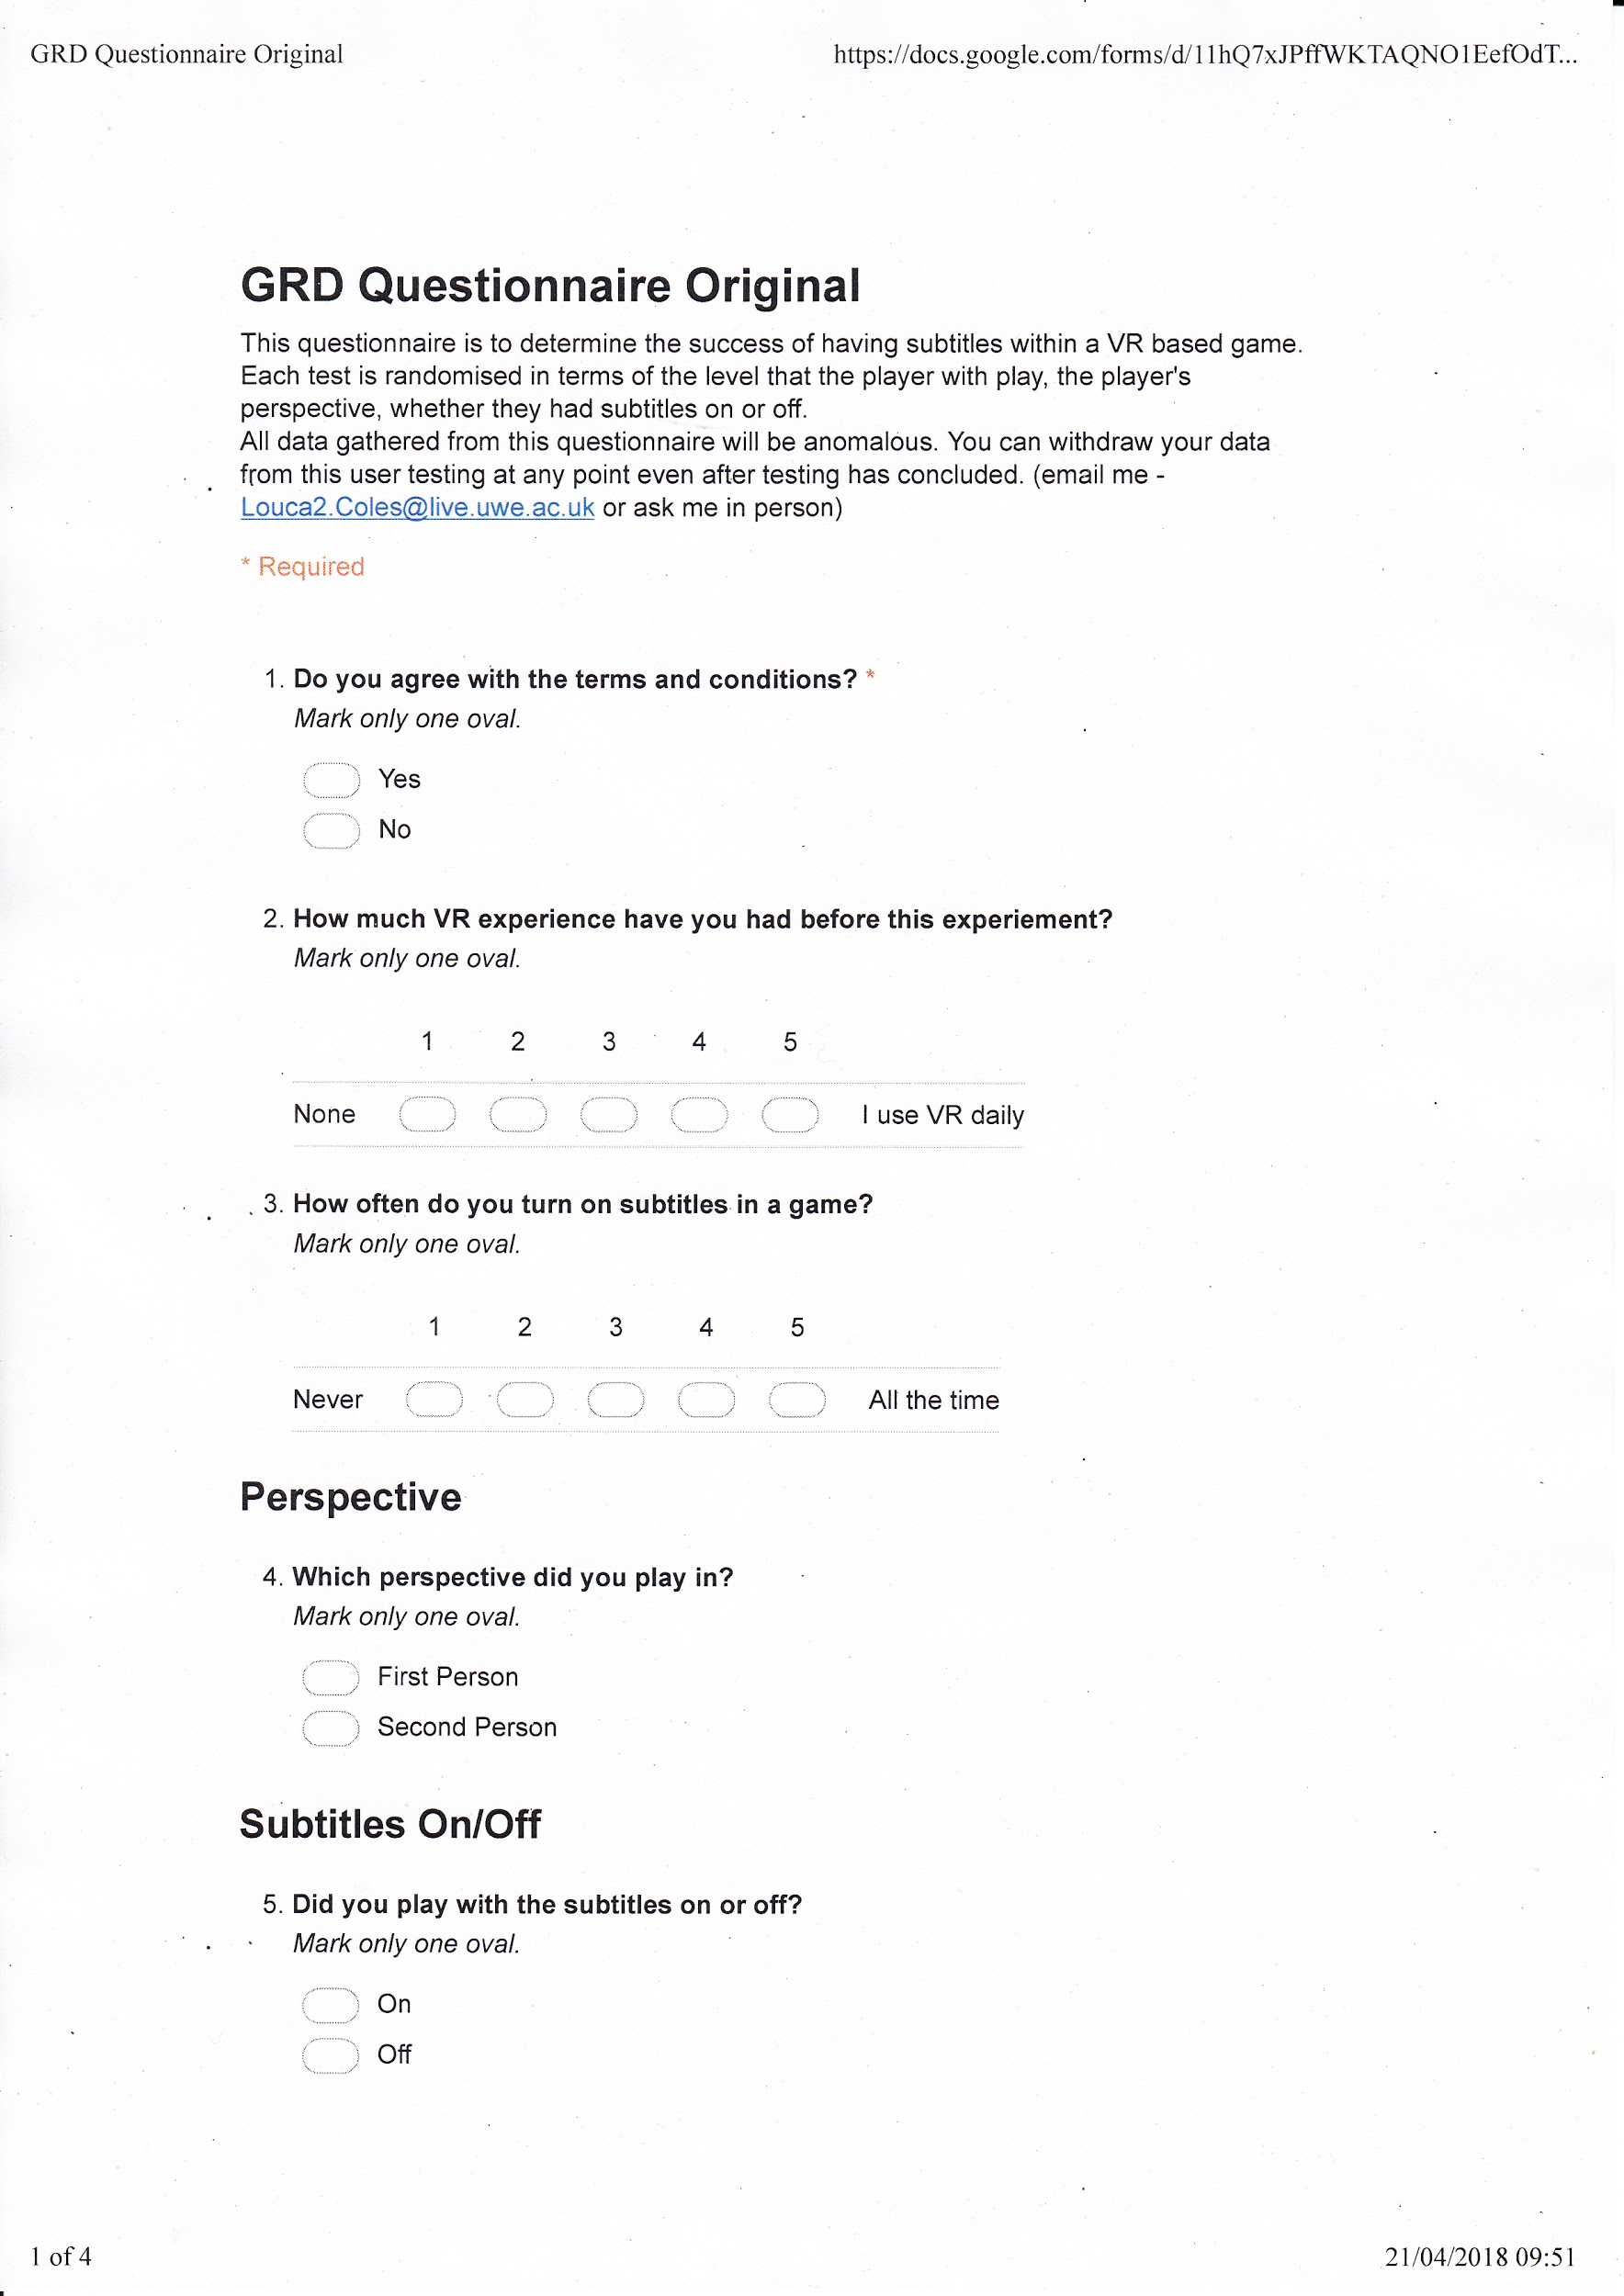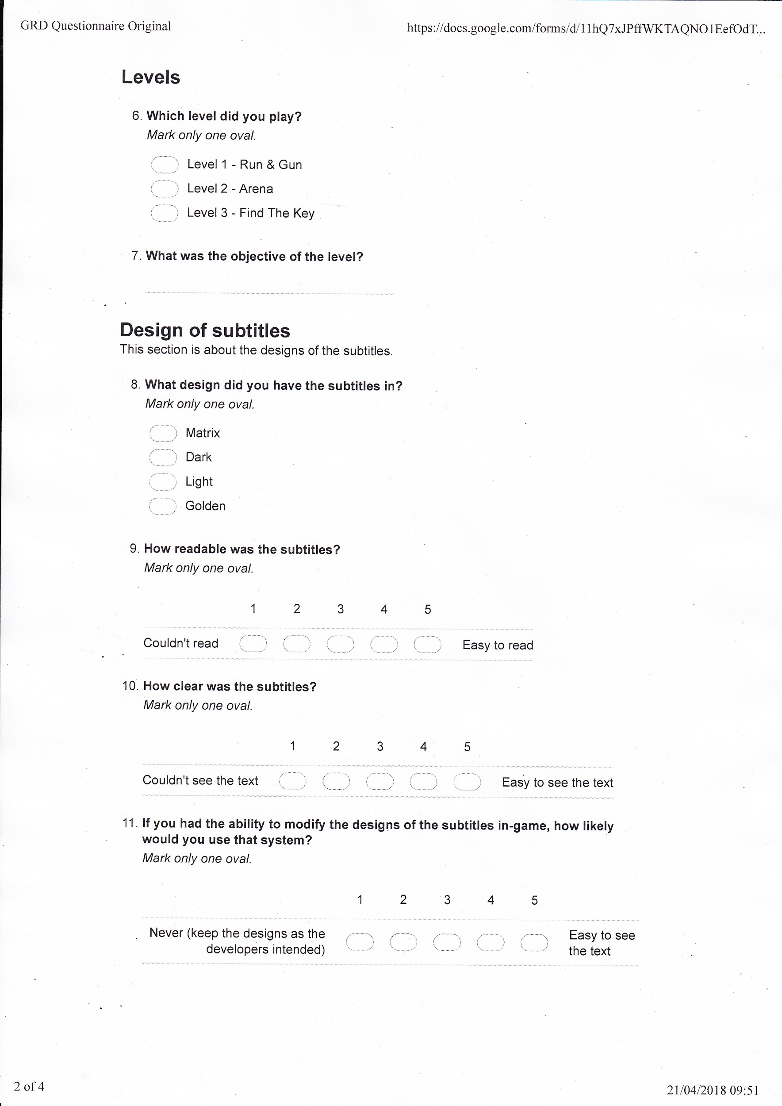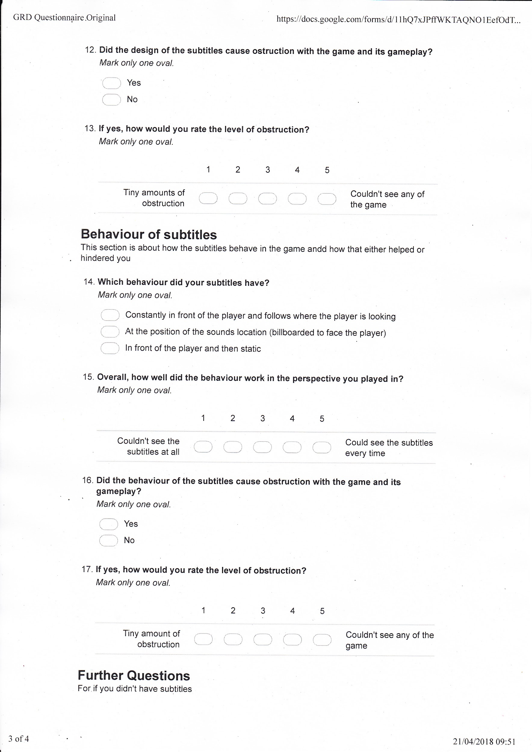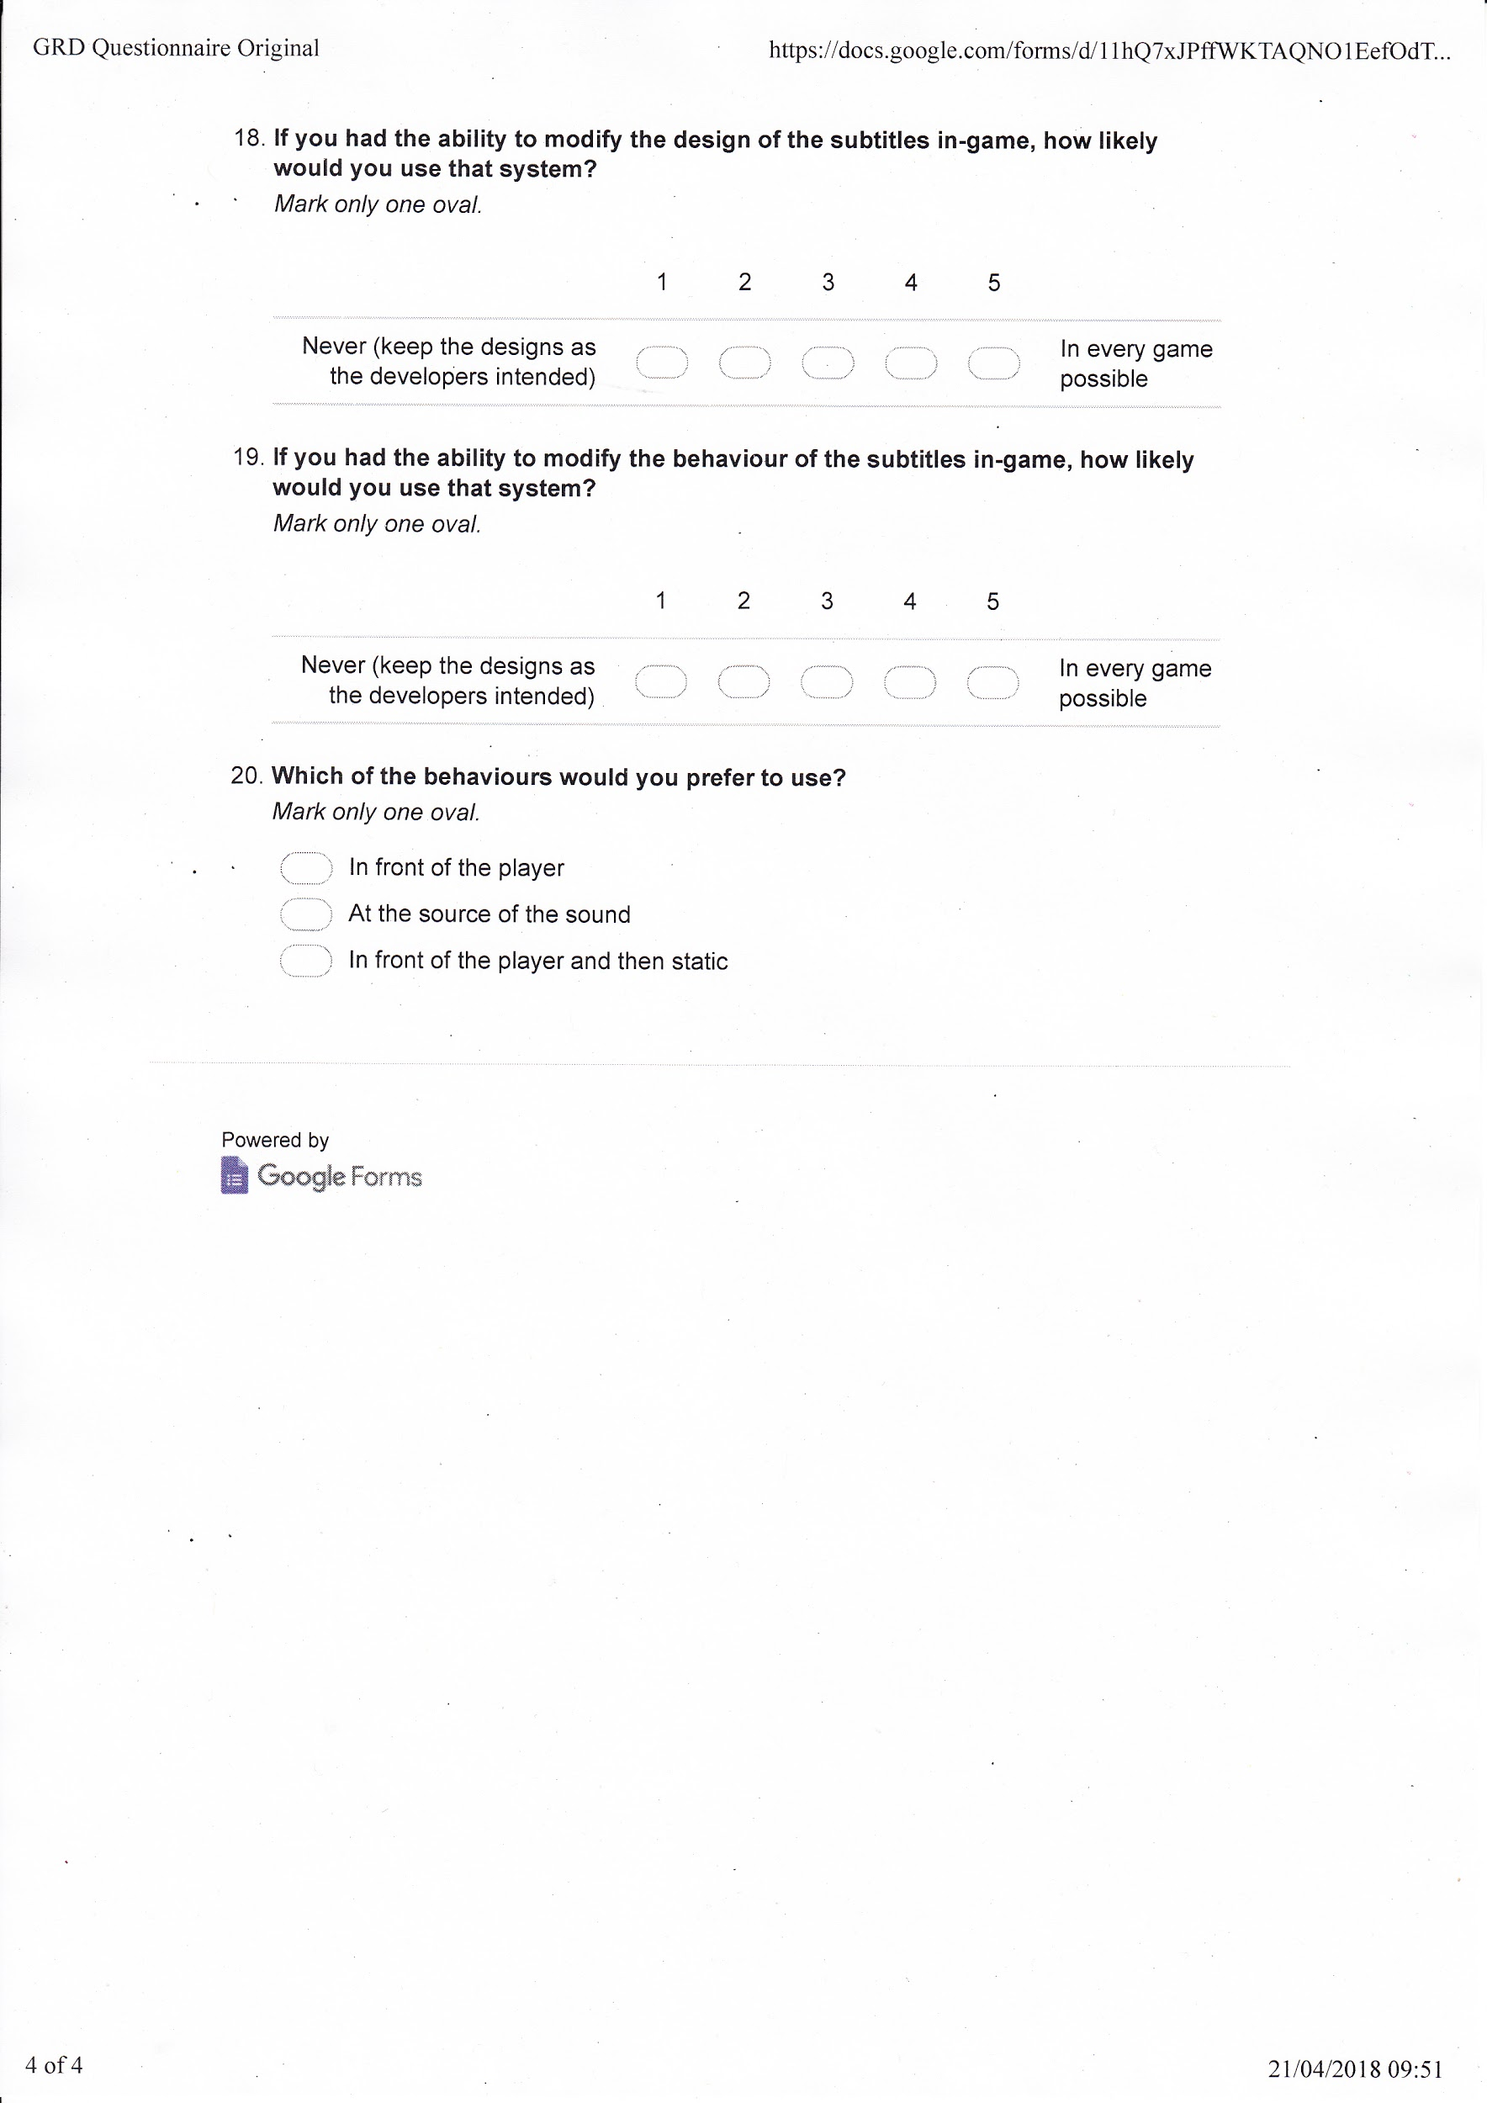

Figure 2. Improved Questionnaire

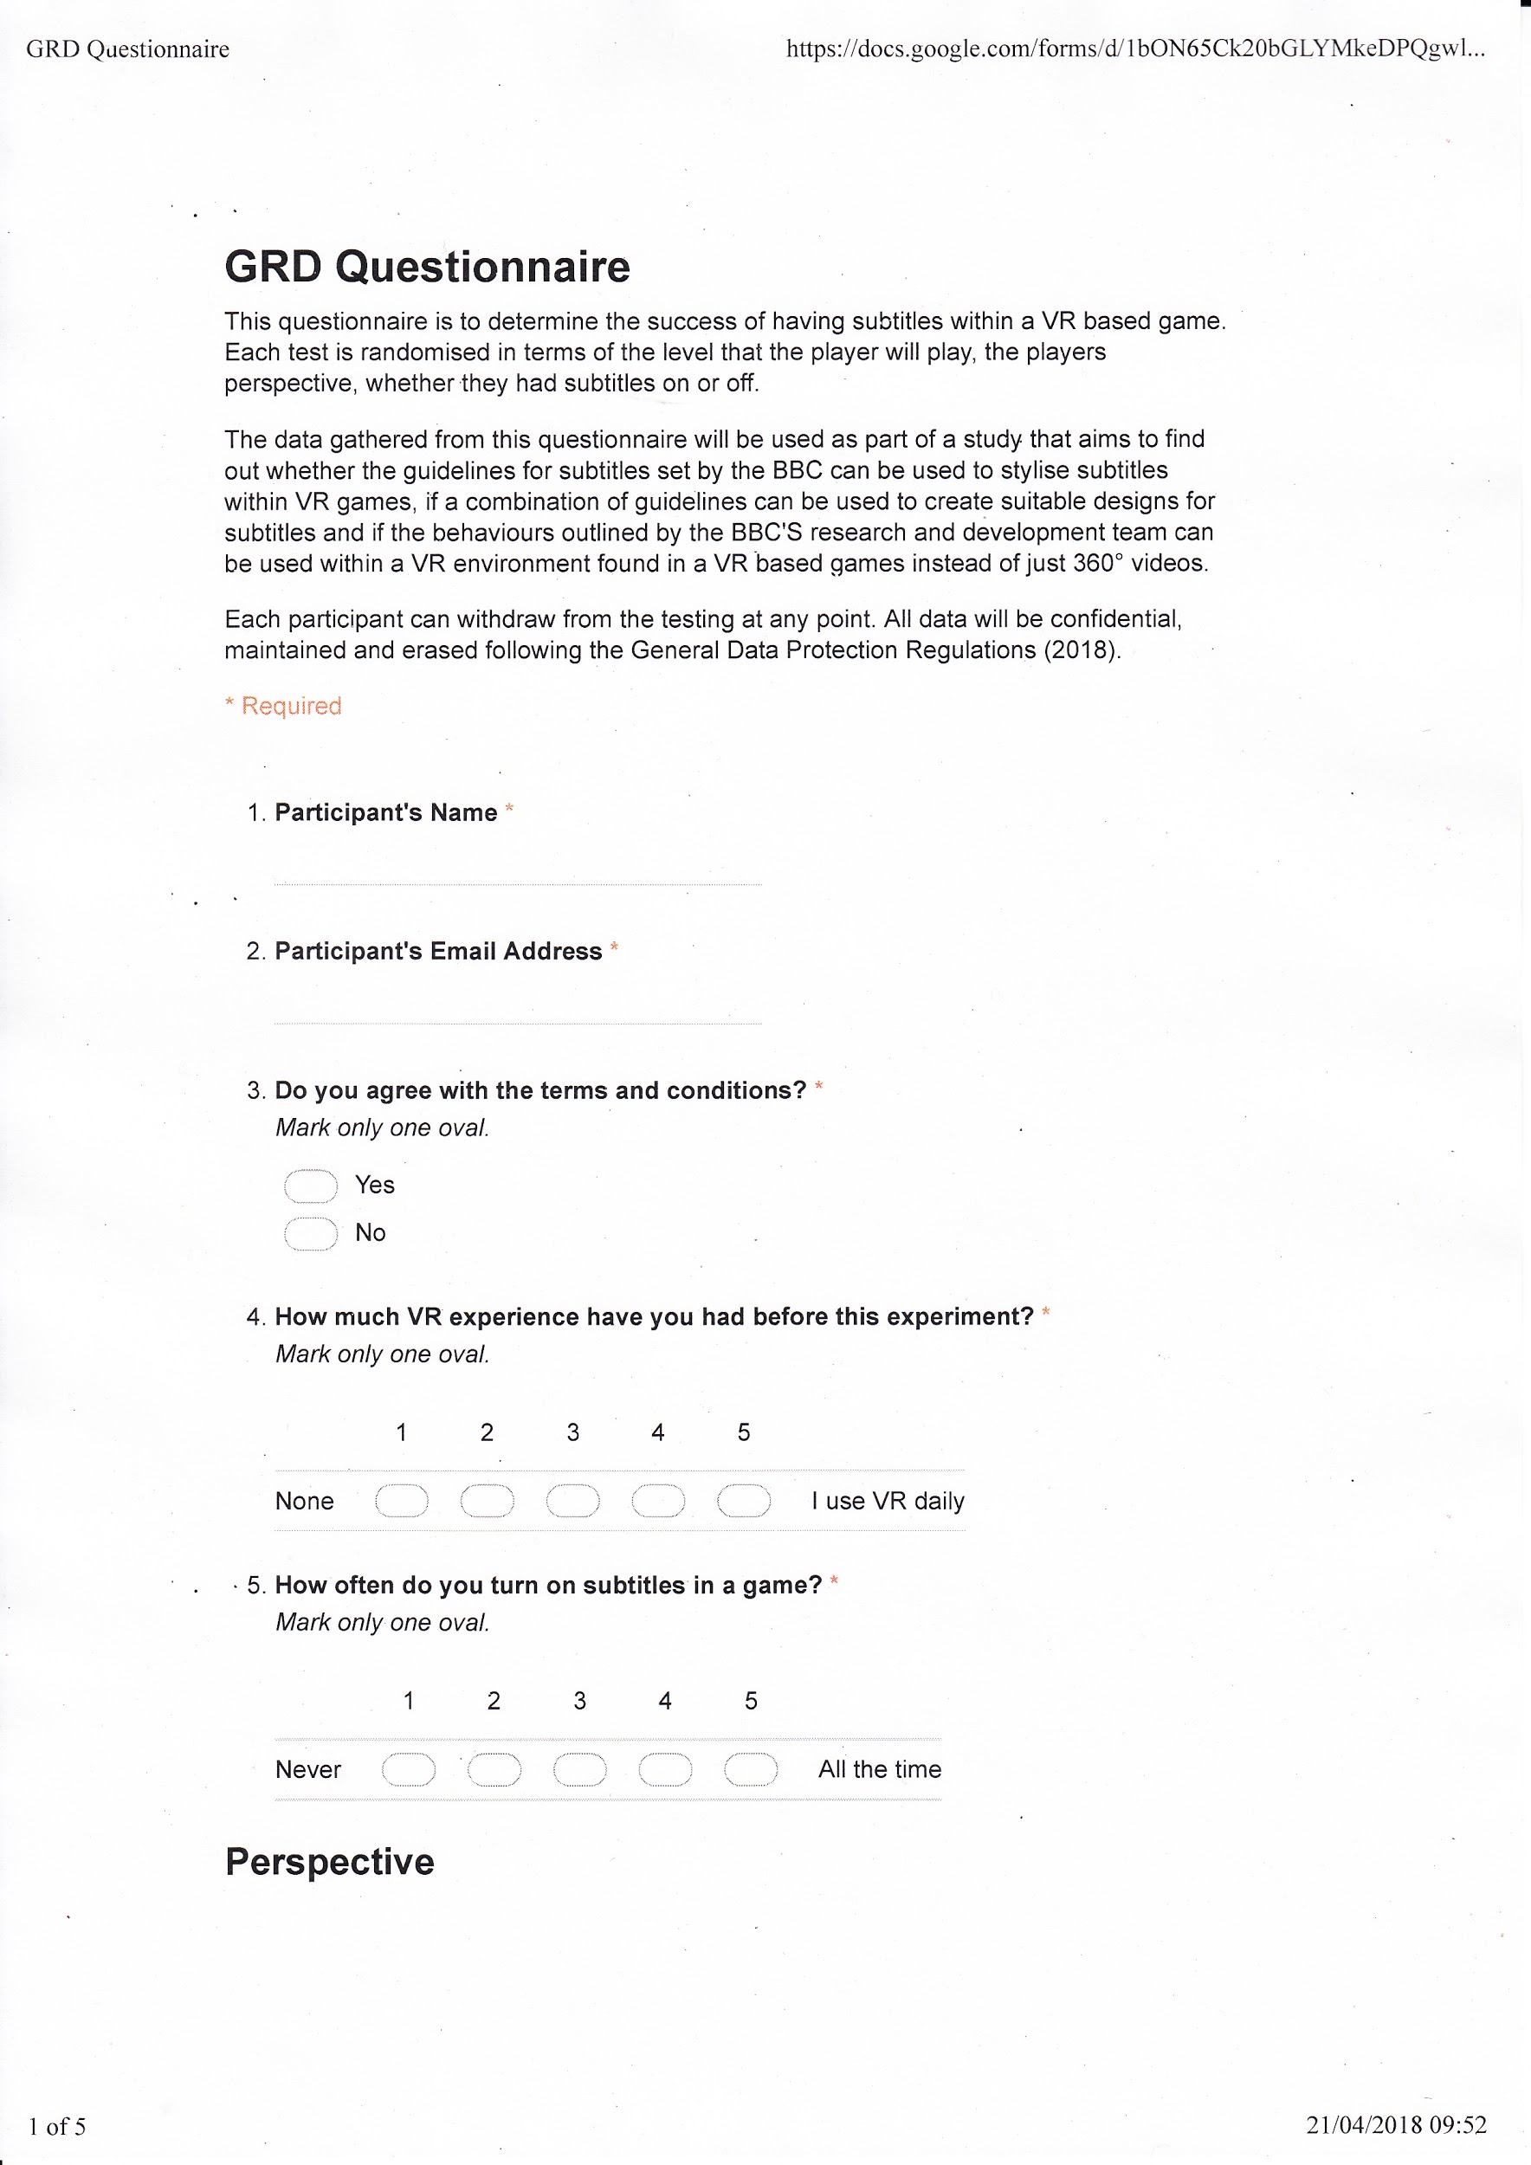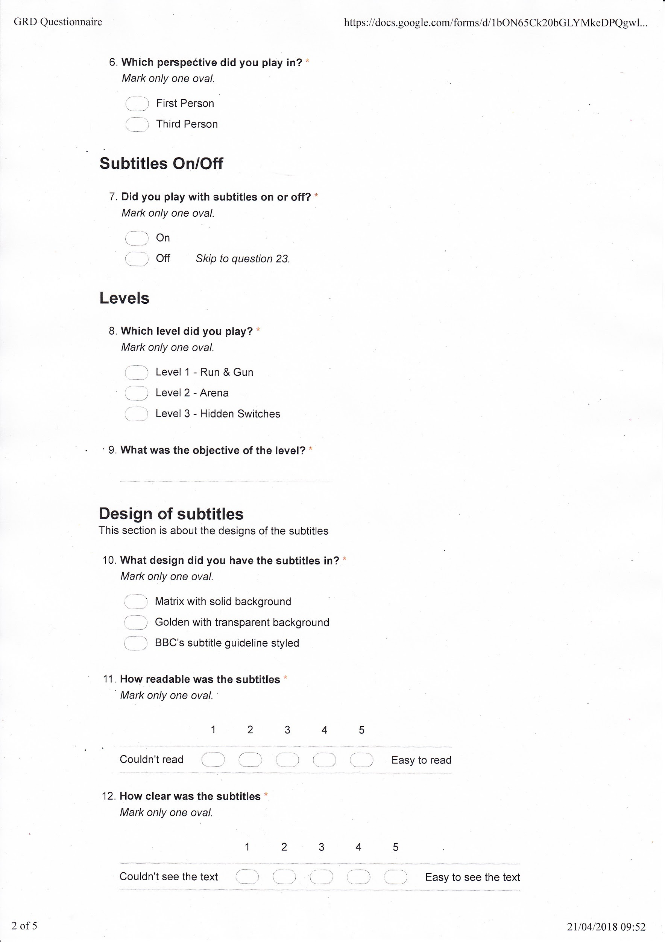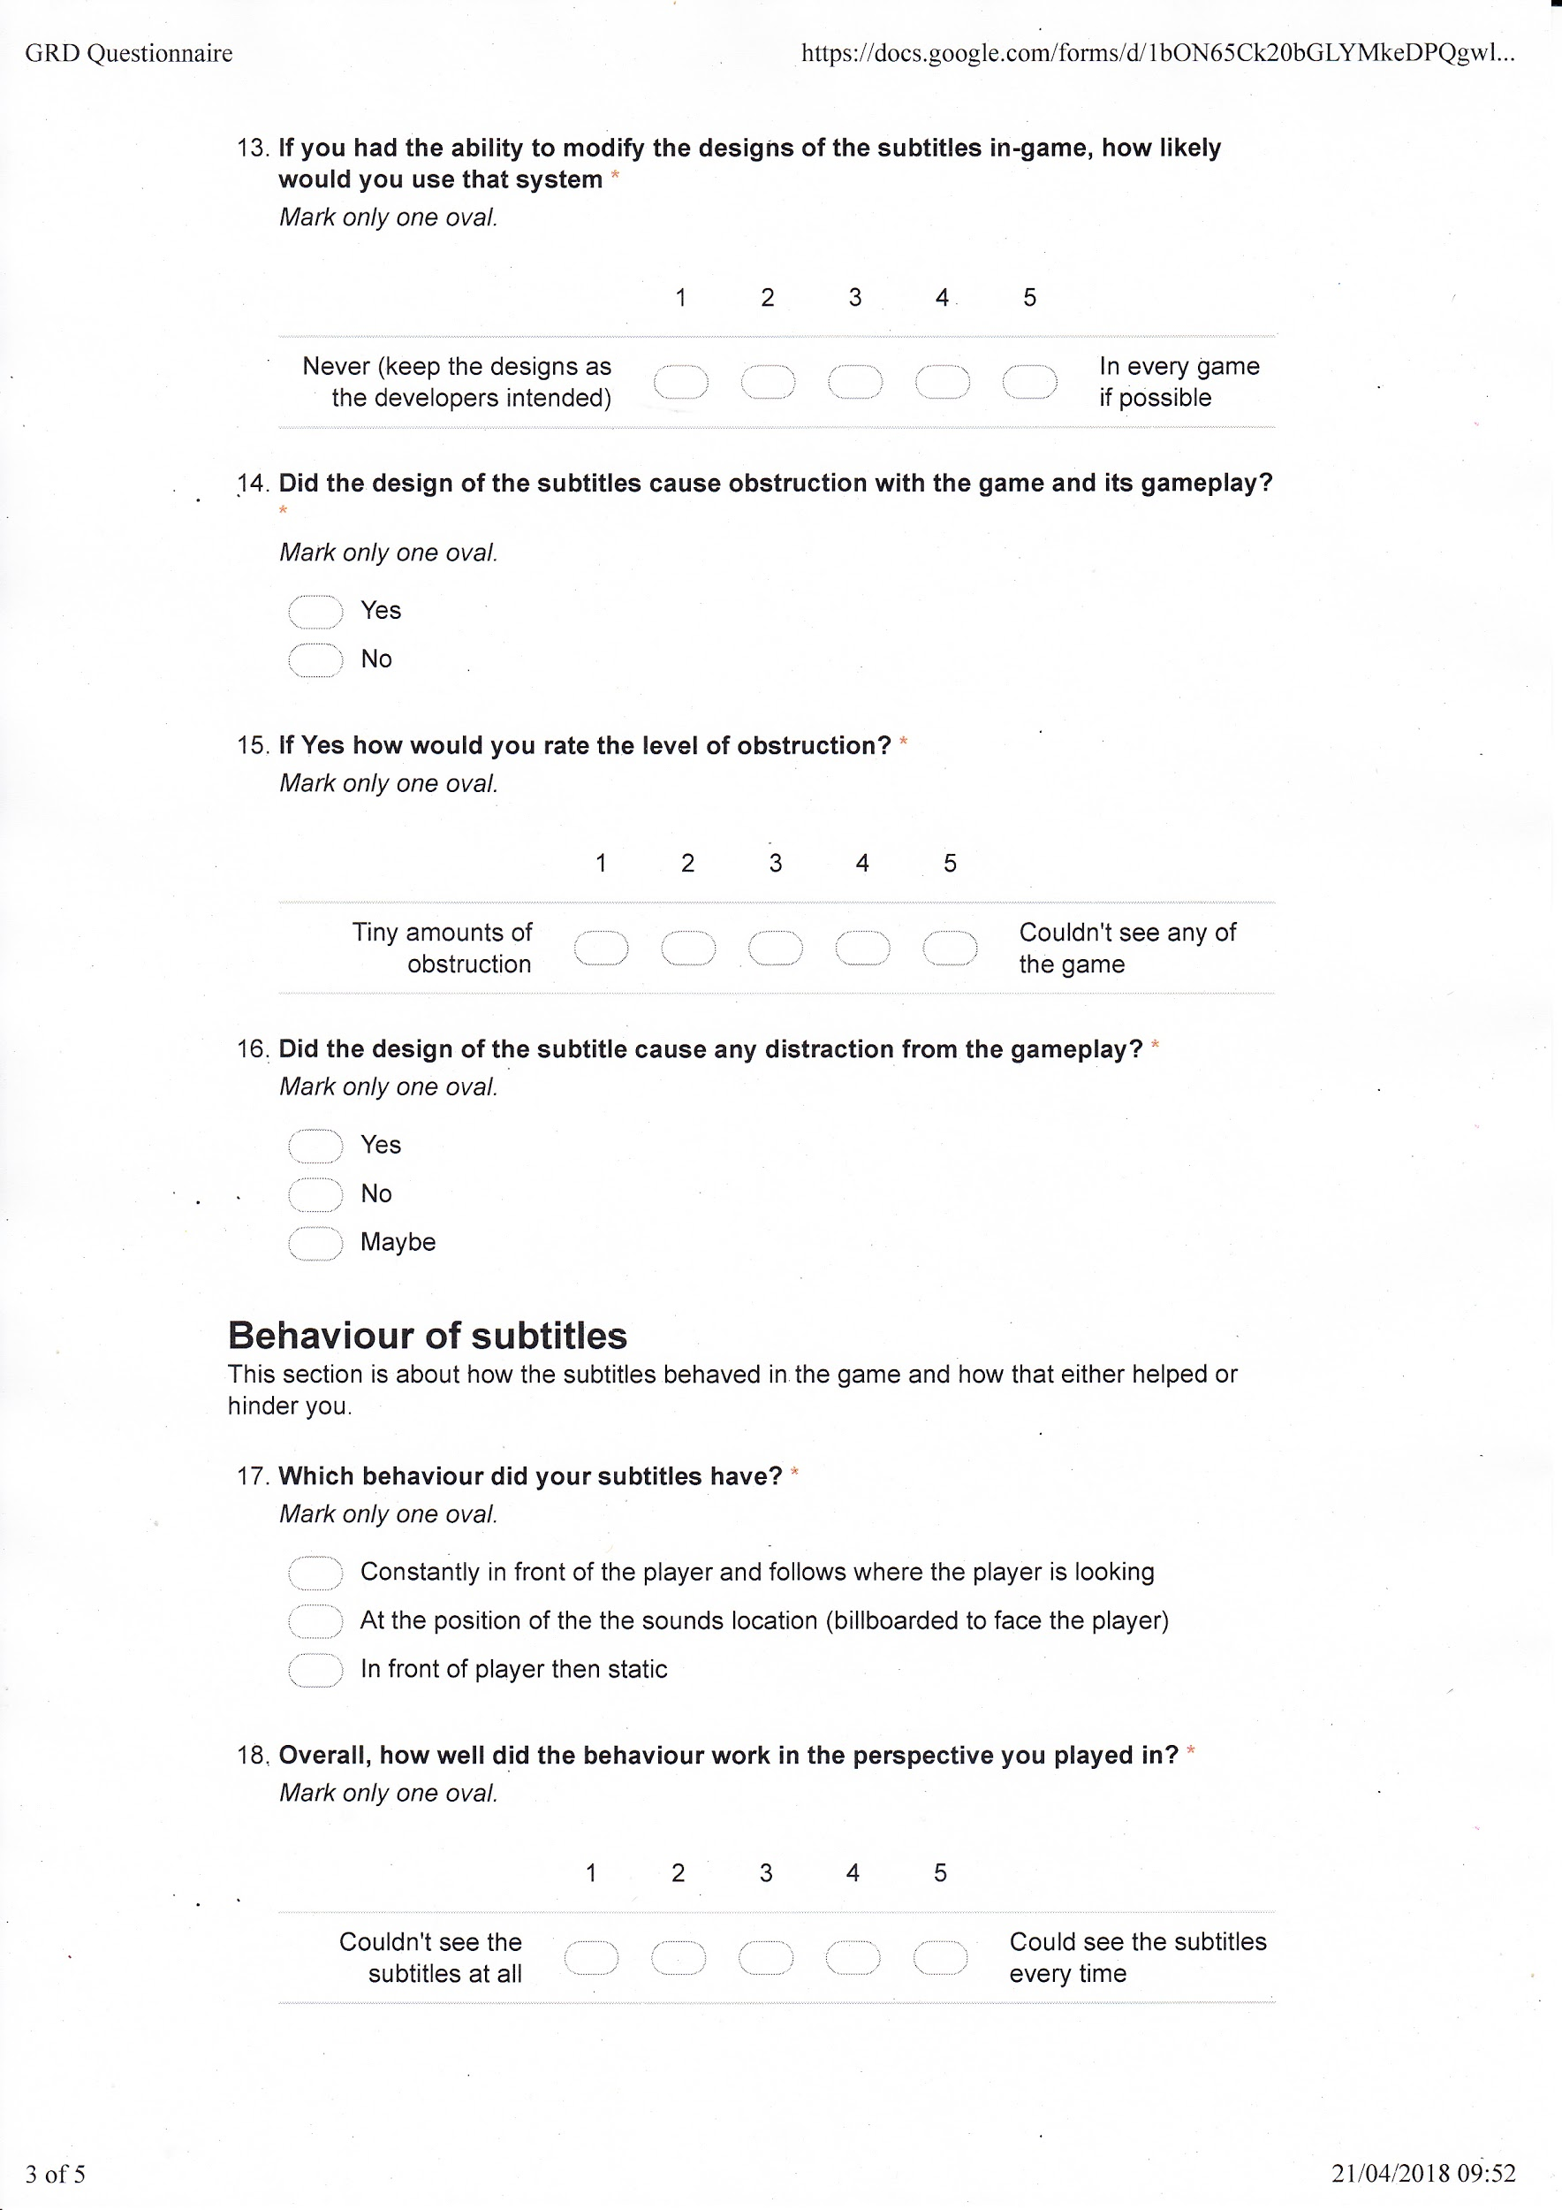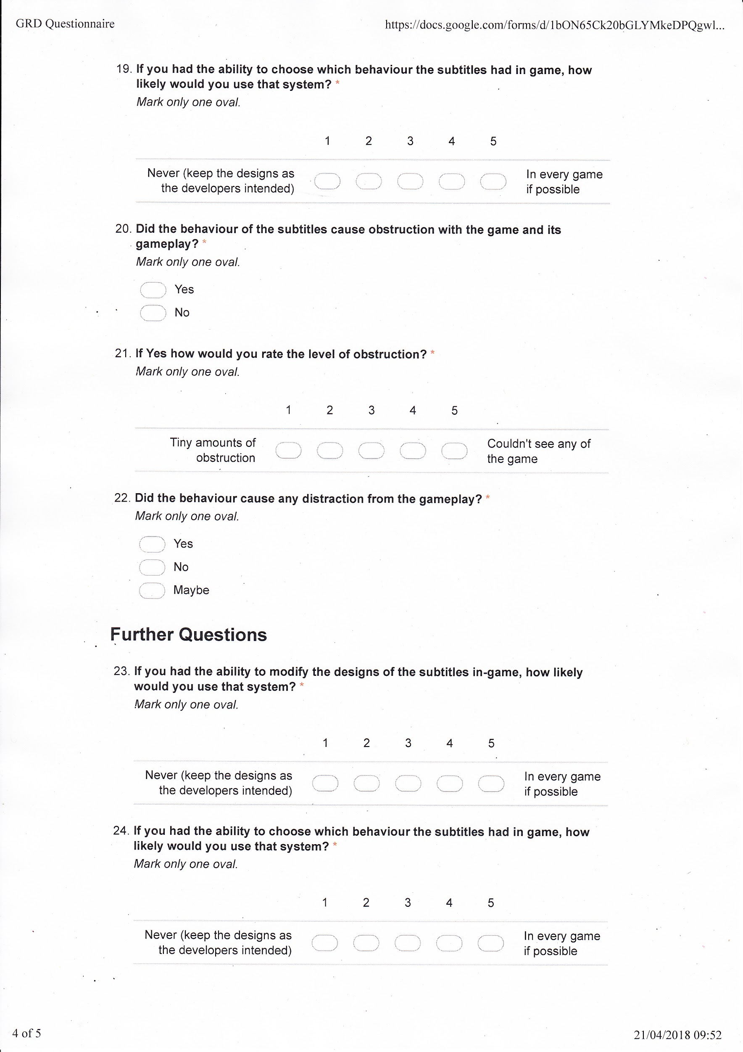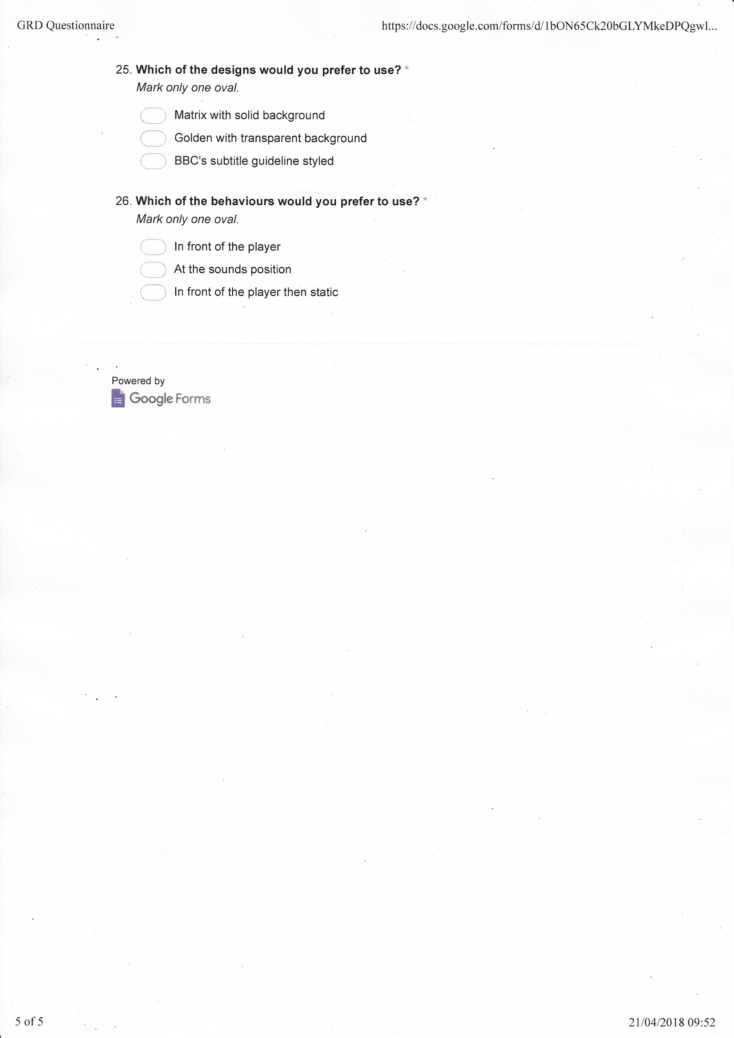

Figure 3. Pie Chart showing the percentage of behaviours that were played in the initial testing

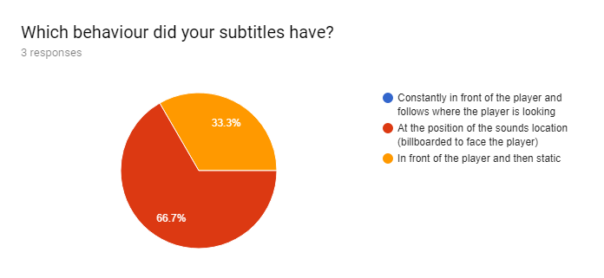

Figure 4. Bar chart showing the ratings of the behaviours in the testers respective perspective in the initial testing

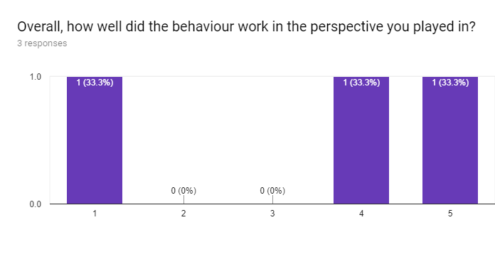

Figure 5. Pie chart showing the level of obstruction caused by the behaviours of the subtitles during the initial testing

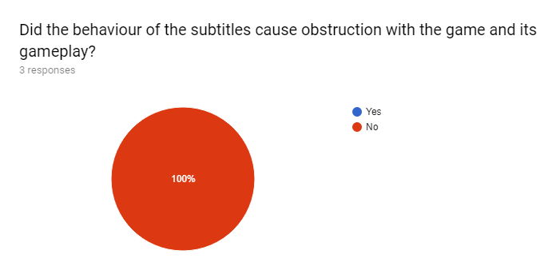

Figure 6. Pie chart showing the favorability of behaviours in the initial testing

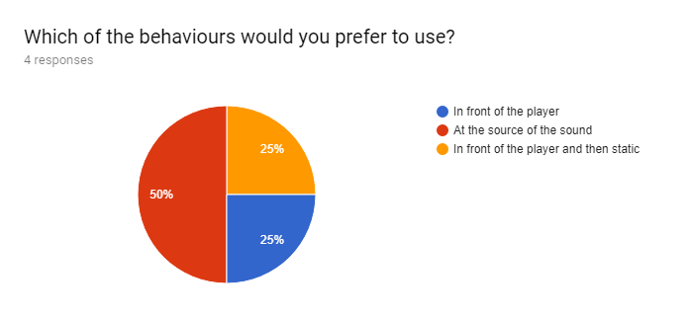

Figure 7. Pie chart showing the designs tested during the improved user testing

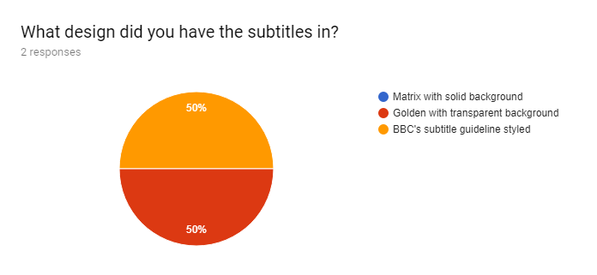

Figure 8. Bar chart showing the readability of the subtitles during the improved user testing

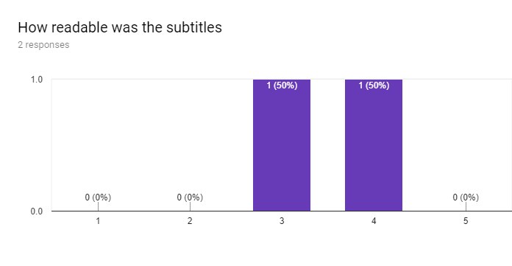

Figure 9. Bar chart showing the clearness of the subtitles during the improved user testing

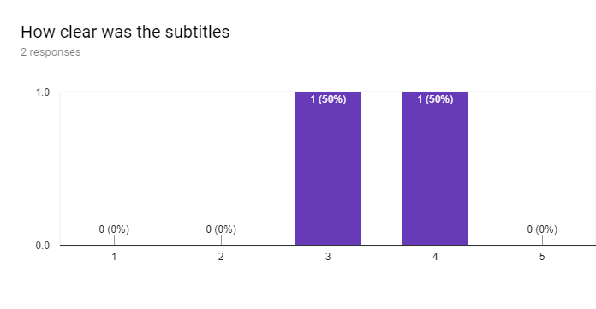

Figure 10. Pie chart showing the level of obstruction during the improved user testing

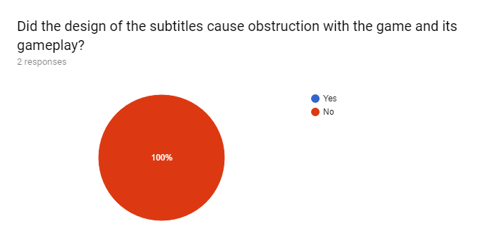

Figure 11. Pie chart showing the level of distraction during the improved user testing

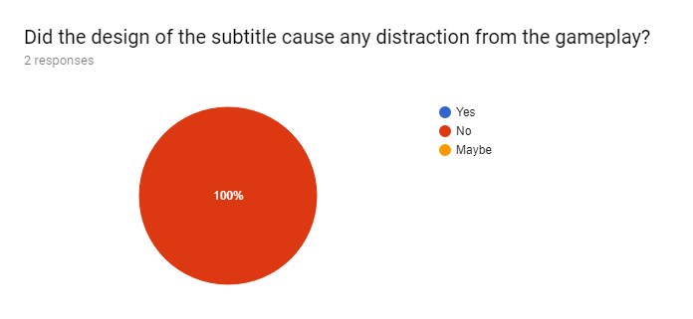

Figure 12. Pie chart showing the behaviours of the subtitles during the improved user testing

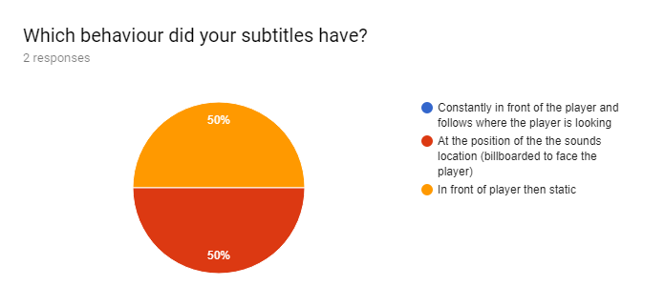

Figure 13. Bar chart showing the rating of the behaviours working in the user’s perspective

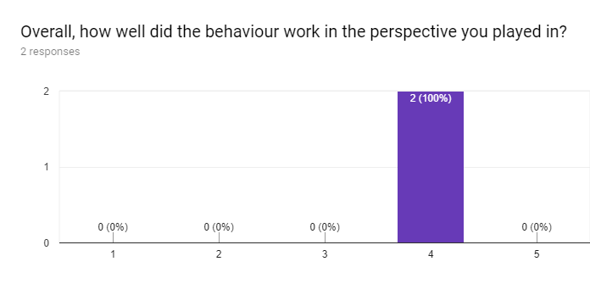

Figure 14. Pie chart of the level of obstruction caused by the behaviours

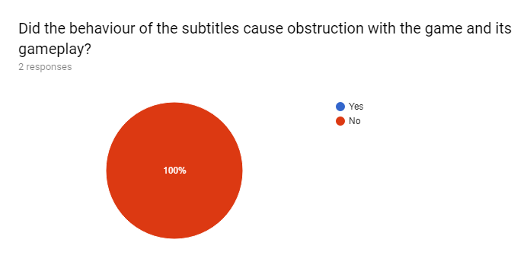

Figure 15. Pie chart of the level of distraction caused by the behaviours

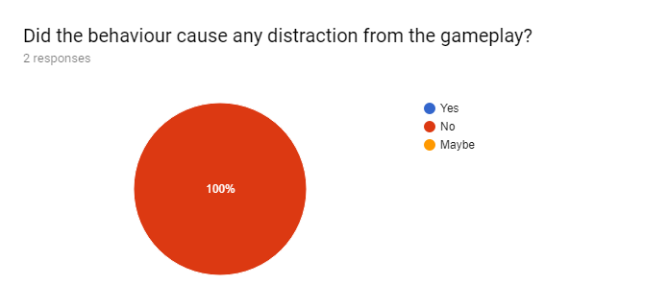

Figure 16. Pie chart showing the preferability between the behaviours in the improved user testing

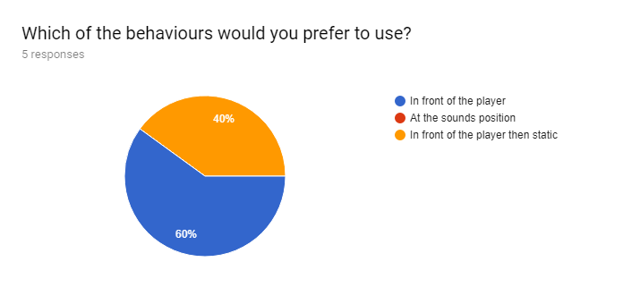

**VIII. WRITER PROFILE**

|  |  |
| --- | --- |
| Louca2.Coles@live.uwe.ac.uk | Louca Coles received a First-Class undergraduate degree in Games Technology at the University of the West of England. He is currently doing a master’s degree in Commercial Games Development at the University of the West of England. |